Docker Track
Assignment Question
Question 1
Configuring and persisting data for a containerized application.
Objective:
Learn how to containerize a stateful application from scratch, configure it entirely through environment variables, and use Docker volumes to persist data beyond the container's lifecycle.

Tasks:
➢ Write a Dockerfile for the provided Visitor Logger Flask application (see starter code) that builds a working image, without modifying the application source.
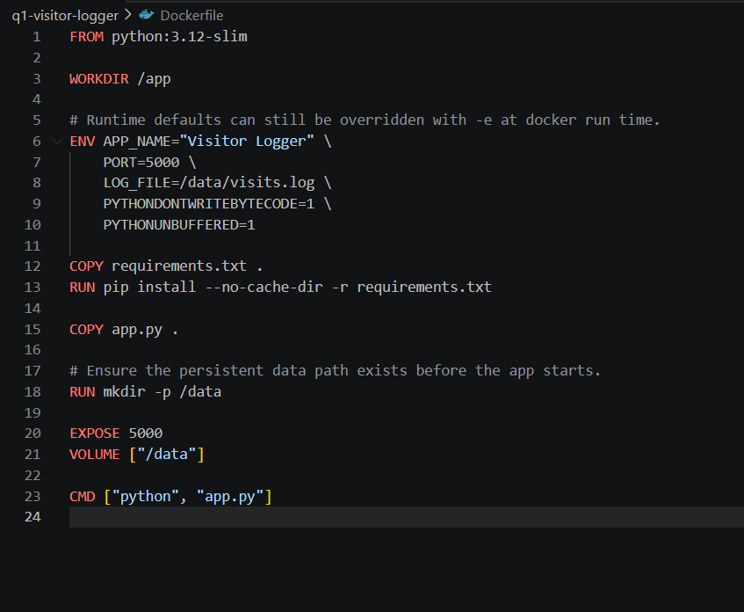
➢Build the image and tag it appropriately.
Docker build -t visit-logger .
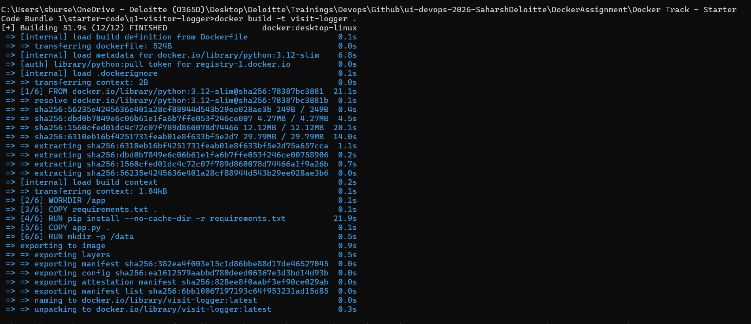
Docker images
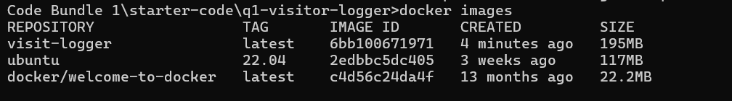

➢ Run the container, overriding at least two of the app's environment variables (APP_NAME, PORT) at runtime using -e — i.e. without editing the Dockerfile.
docker run -d --name visitor-app -p 8081:8081 -e APP_NAME="Visitor Logger Runtime" -e PORT=8081 -e LOG_FILE=/data/visits.log -v visitor_logs_data:/data visit-logger
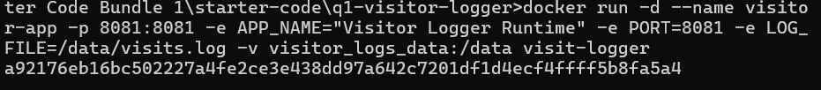
Breakdown:
docker run
Starts a container from an image.

-d
Runs the container in detached mode, so it stays in the background.

--name visitor-app
Gives the container the name visitor-app.

-p 8081:8081
Maps port 8081 on your machine to port 8081 inside the container.

-e APP_NAME="Visitor Logger Runtime"
Sets the app name environment variable inside the container.

-e PORT=8081
Tells the Flask app to listen on port 8081 inside the container.

-e LOG_FILE=/data/visits.log
Tells the app to write logs to /data/visits.log.

-v visitor_logs_data:/data
Mounts the named Docker volume visitor_logs_data to /data so log data persists even if the container is removed.

visit-logger
image

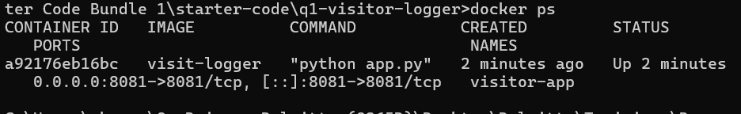
➢Create and mount a named Docker volume to the path the application uses for its log file, so the log data lives outside the container.
docker volume create visitor_logs_data

➢Use the running container's endpoints to log at least three visits and confirm they were recorded. 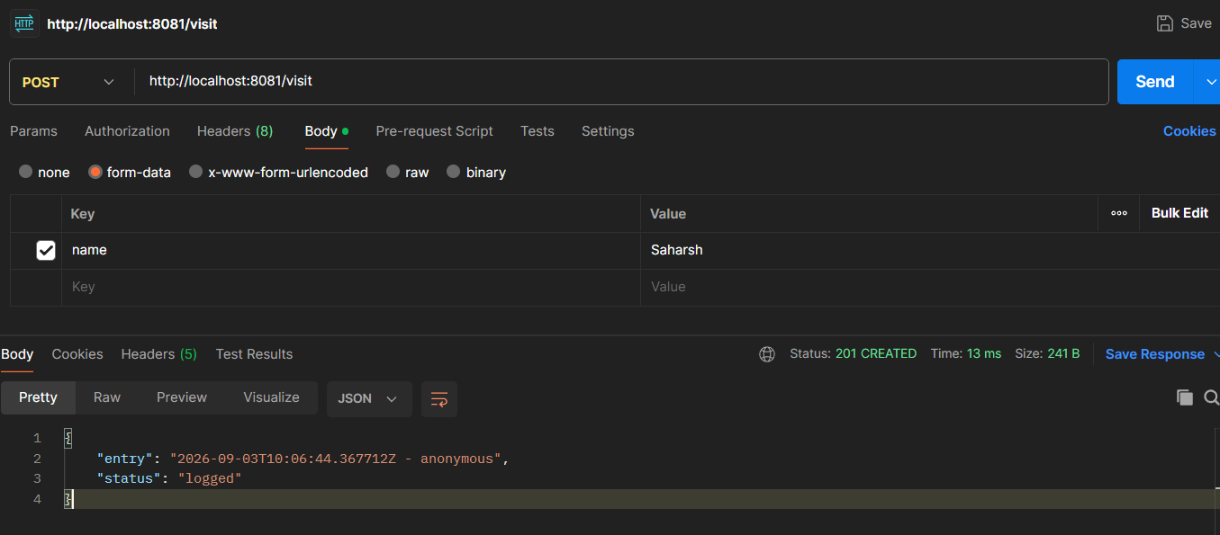
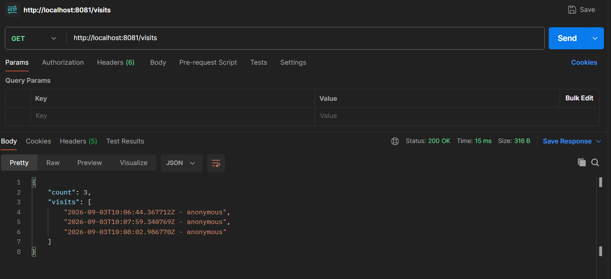
➢ Stop and remove the container, then create a brand-new container from the same image and the same named volume, and confirm the previously logged visits are still present.
docker stop visitor-app
docker rm visitor-app
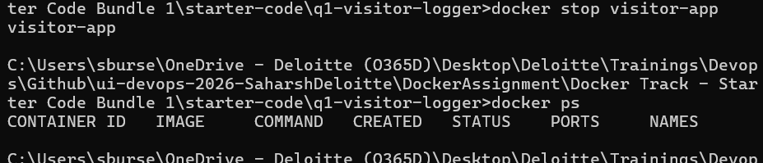

docker run -d --name visitor-app-2 -p 8081:8081 -e APP_NAME="Visitor Logger Recreated" -e PORT=8081 -e LOG_FILE=/data/visits.log -v visitor_logs_data:/data visit-logger
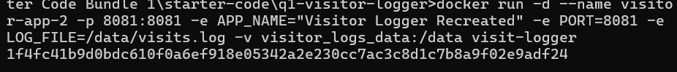
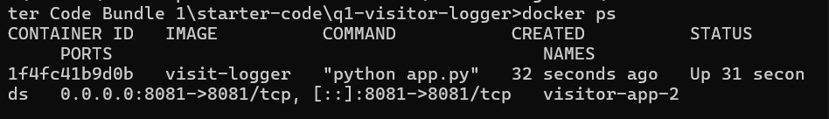
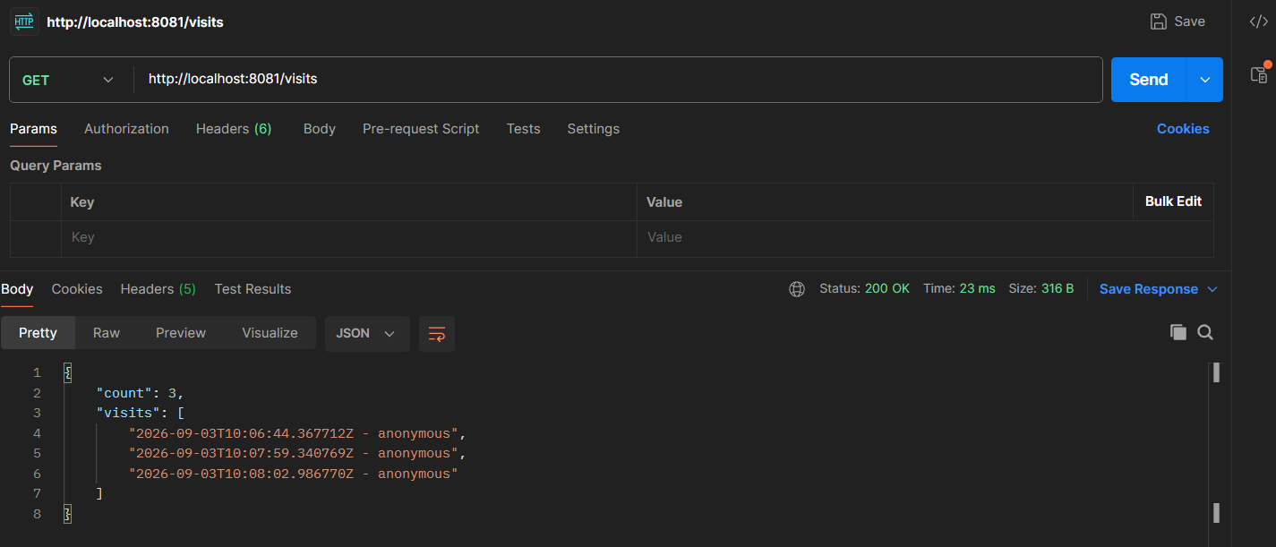

➢ Additionally, repeat the persistence test using a bind mount instead of a named volume, and explain when you would choose one over the other.
docker run -d --name visitor-app-bind -p 8082:8082 -e APP_NAME="Visitor Logger Bind" -e PORT=8082 -e LOG_FILE=/data/visits.log -v "%cd%\bind-logs:/data" visit-logger

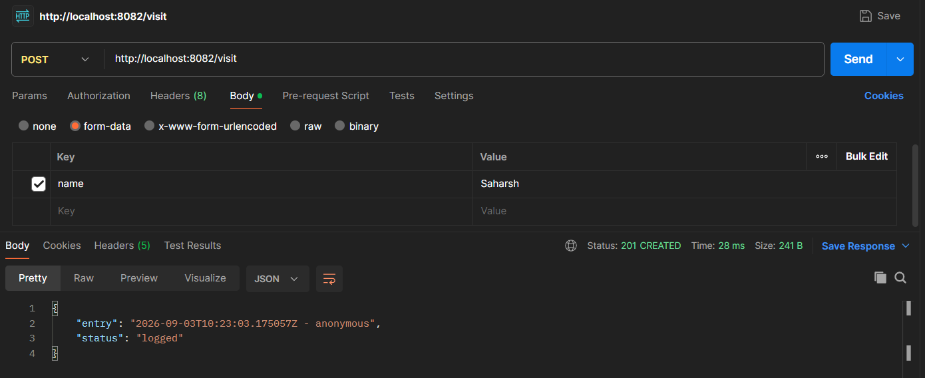
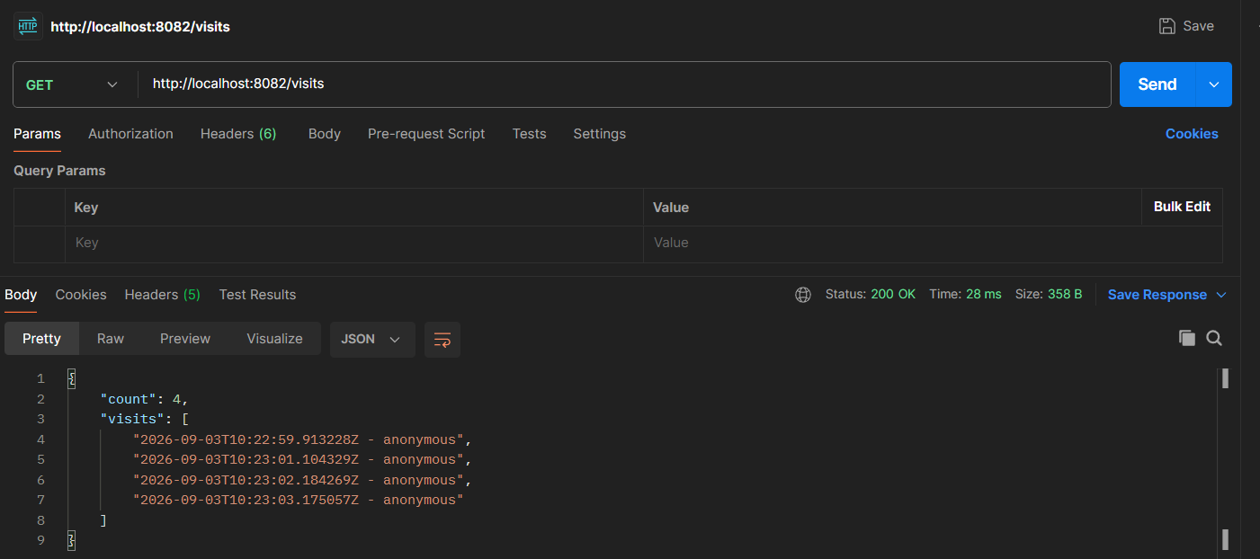
docker stop visitor-app-bind
docker rm visitor-app-bind

docker run -d --name visitor-app-bind-2 -p 8082:8082 -e APP_NAME="Visitor Logger Bind Recreated" -e PORT=8082 -e LOG_FILE=/data/visits.log -v "%cd%\bind-logs:/data" visit-logger
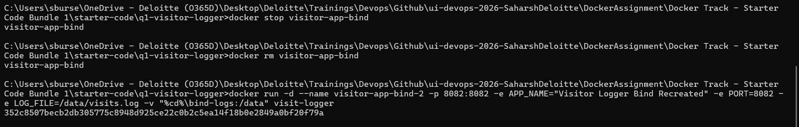
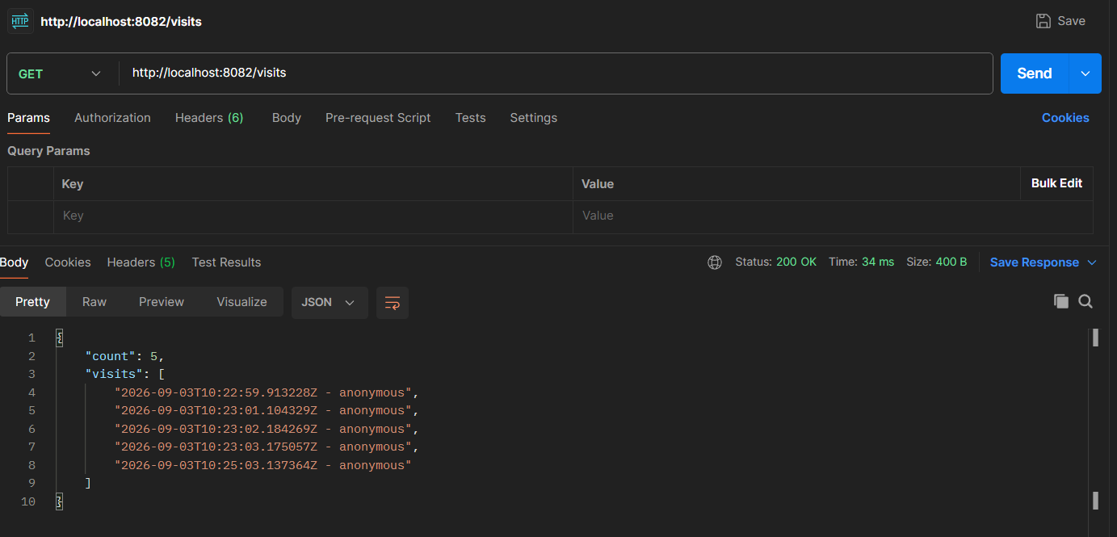

A brief explanation of the difference between named volumes and bind mounts.
Named volumes are managed by Docker. Docker stores the data for you, so they are the better default for persistent app data in containers. They are portable, cleaner to manage, and less dependent on your host machine layout.
Bind mounts map a specific folder on your host machine directly into the container. That makes the files easy to inspect and edit from Windows, so they are useful for development, debugging, or when you want the host filesystem to be the source of truth.
Choose a named volume when you want reliable persistence with less host coupling and production. Choose a bind mount when you want direct access to the files on your machine and need to see or edit them outside the container and when locally.

Question 2
Orchestrating a two-tier application with Docker Compose.
Objective:
Learn how to use Docker Compose to run and connect a small multi-container application, using a custom network, externalized configuration, and a readiness-aware startup sequence.
Tasks:
➢ Using the provided QuickTasks Flask application (see starter code), write a Dockerfile for the app service — do not modify app.py.
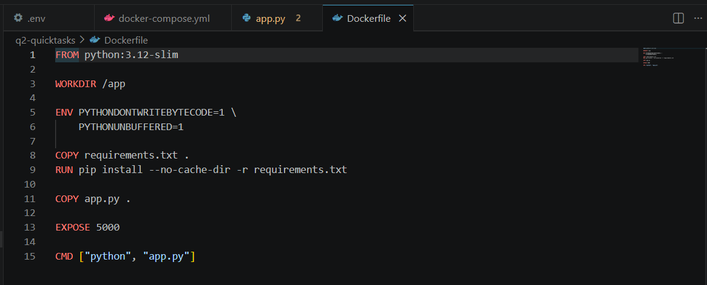
➢ Write a docker-compose.yml that runs two services, app and redis (use the official redis image), connected over a custom user-defined bridge network, not the Compose default network.
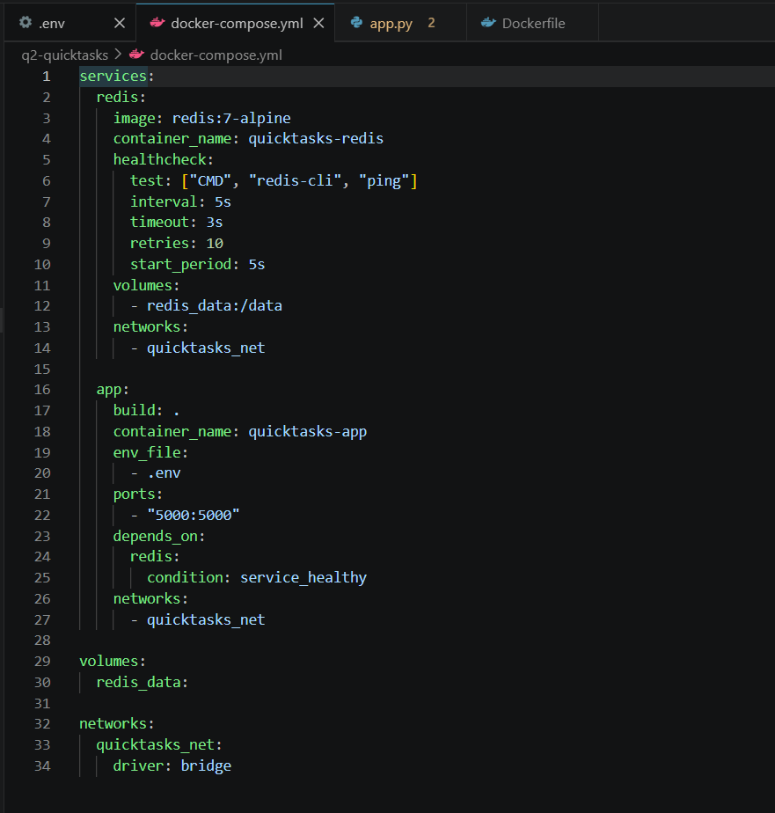
➢ Externalize all configurable values (at minimum REDIS_HOST and REDIS_PORT) using a .env file referenced from docker-compose.yml — do not hardcode them in the Dockerfile or in the compose file's environment block.
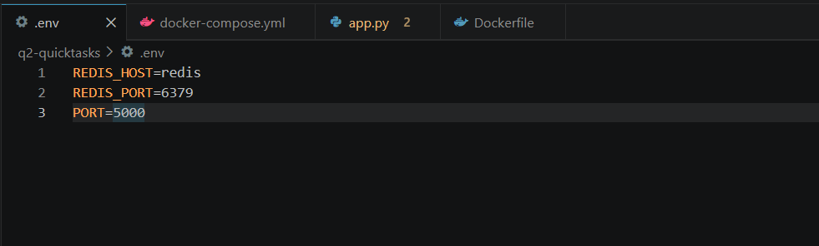
➢ Ensure the app does not attempt to serve requests before Redis is reachable. A plain depends_on is not sufficient on its own — add a healthcheck to the redis service and use depends_on with condition: service_healthy on the app service.
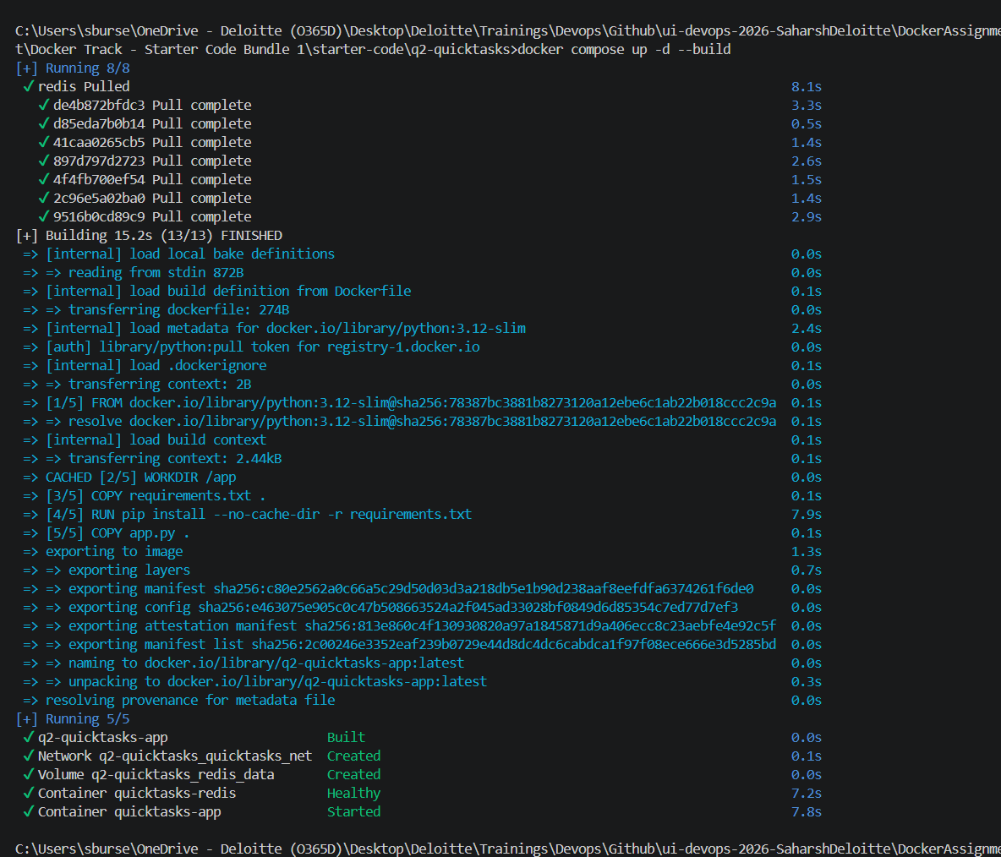

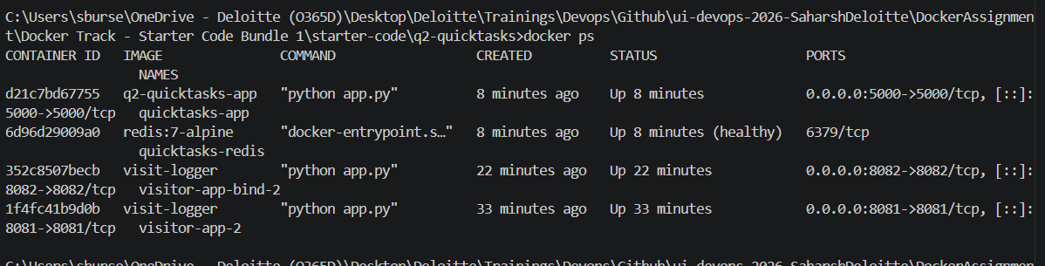

➢ Demonstrate the working stack: add at least four tasks through the API, list them, then bring the stack down and back up and show the tasks are still there.
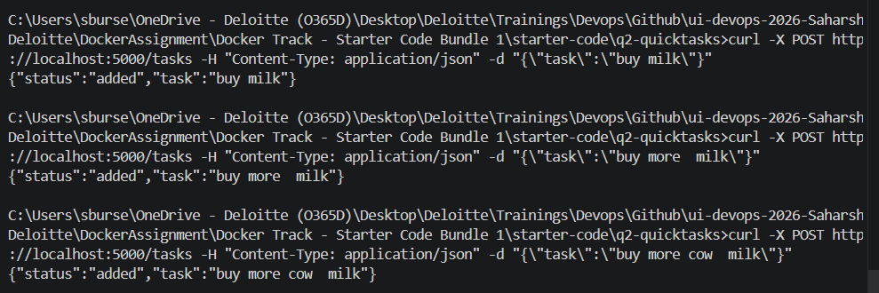
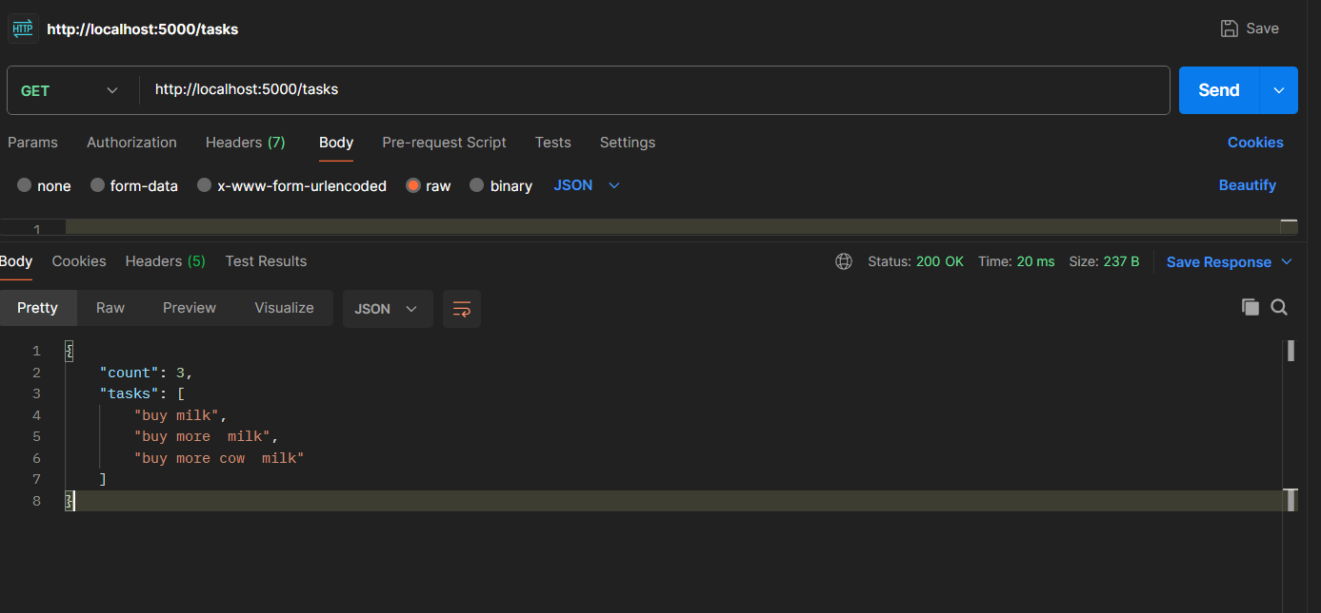

docker compose down
docker compose up -d

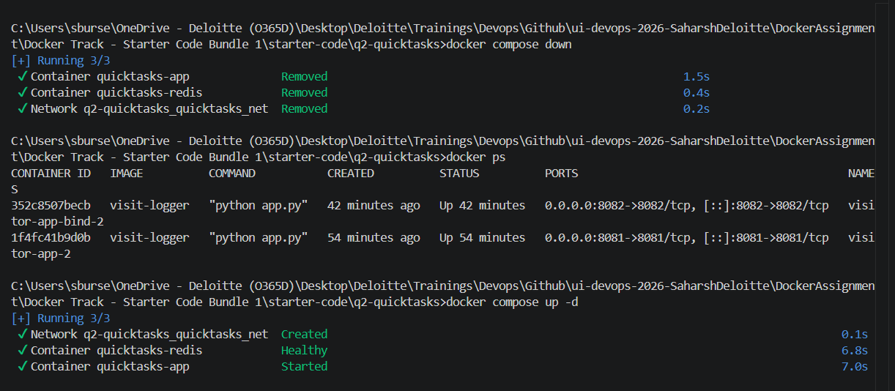
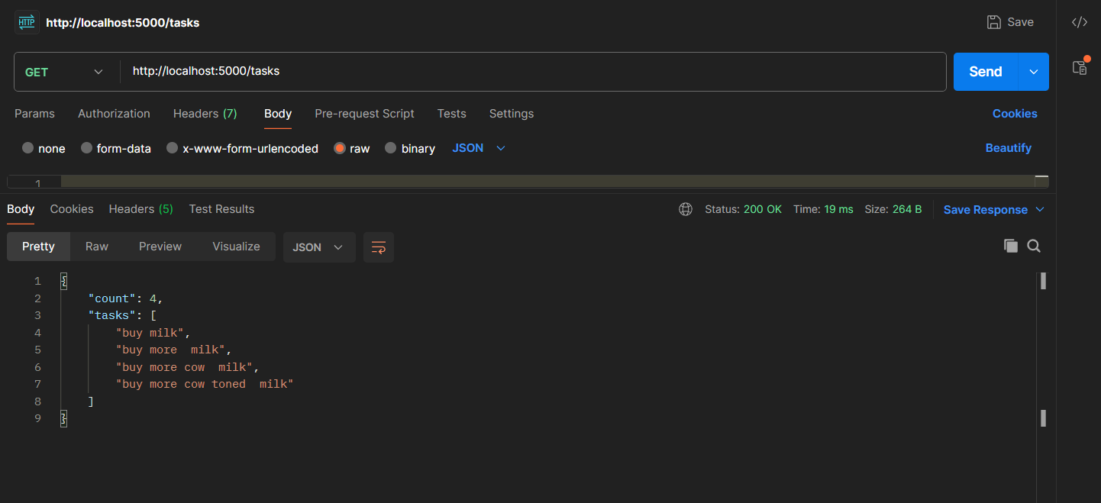

➢ Run docker network inspect on your custom network and explain what the output shows about how the two containers find and reach each other.
docker network inspect q2-quicktasks_quicktasks_net
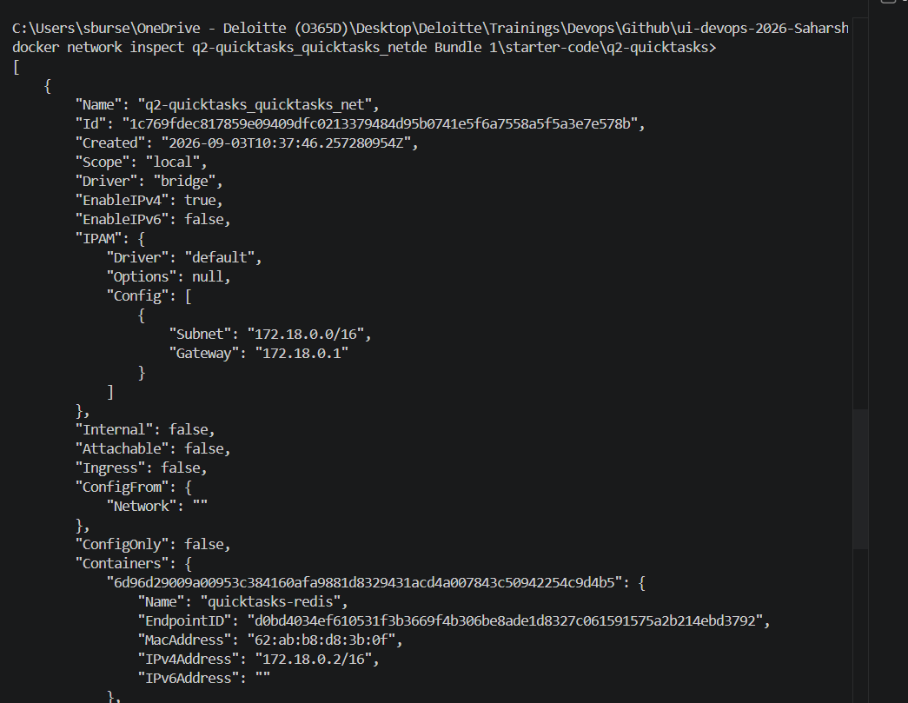
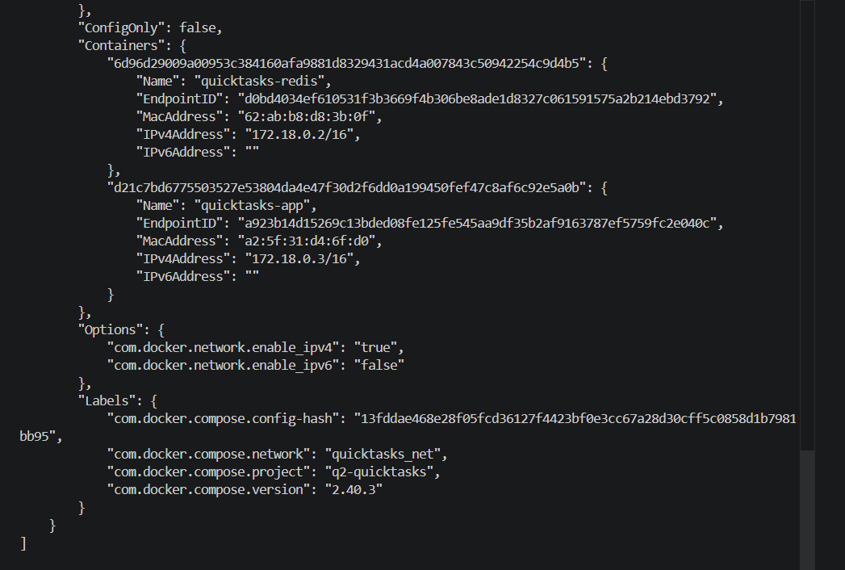
A brief explanation of why a healthcheck-based dependency is more reliable here than a plain
depends_on.
A plain depends_on only controls start order, not readiness. It can start the app right after the Redis container process starts, even if Redis is still initializing and not yet accepting connections.
A healthcheck-based dependency is more reliable because the app waits until Redis is actually healthy (for example, redis-cli ping succeeds). That prevents race conditions at startup, reduces transient connection errors, and makes stack boot behavior predictable.

Question 3
Reducing image size and hardening a container with a multi-stage build.
Objective: Compare single-stage and multi-stage builds for an application with a compile step, and apply container security hardening to the final image.
Tasks:
➢ Using the provided TS Notes API (see starter code), write a single-stage Dockerfile that installs all dependencies (including devDependencies), compiles the TypeScript, and runs the app. Build it, tag it ts-notes:single-stage, and record the final image size.
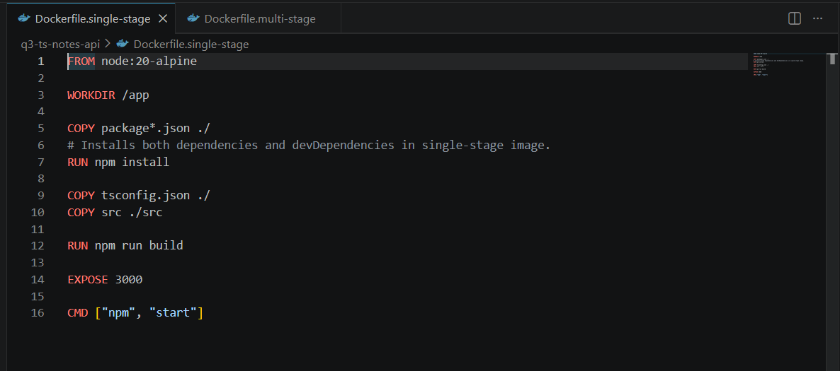
docker build -f Dockerfile.single-stage -t ts-notes:single-stage .
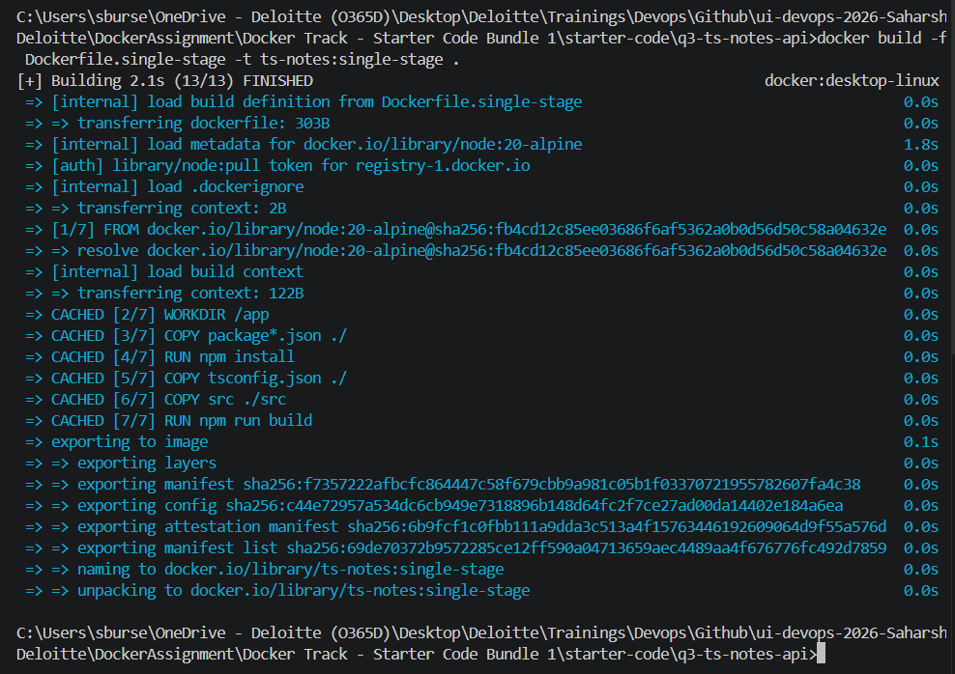

➢ Write a multi-stage Dockerfile for the same application: a build stage that compiles the TypeScript, and a separate, smaller final stage containing only the compiled output and production dependencies. Build it, tag it ts-notes:multi-stage, and record the final image size.
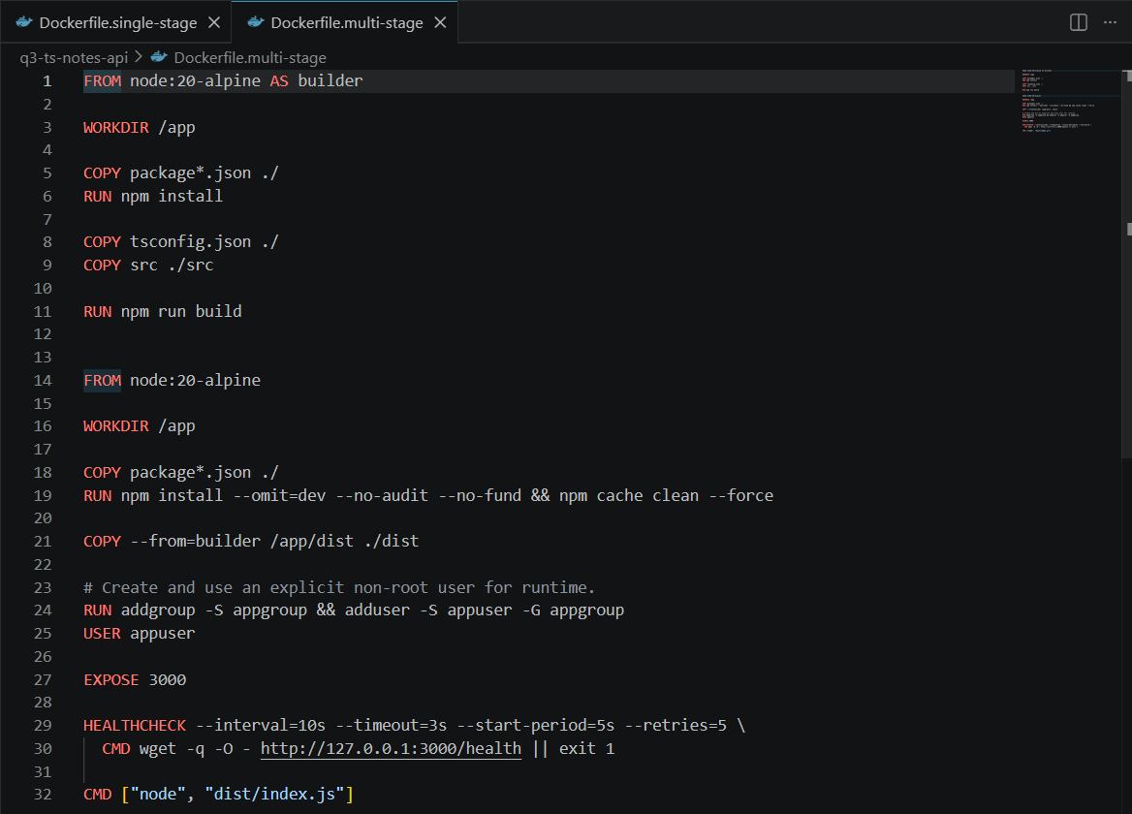
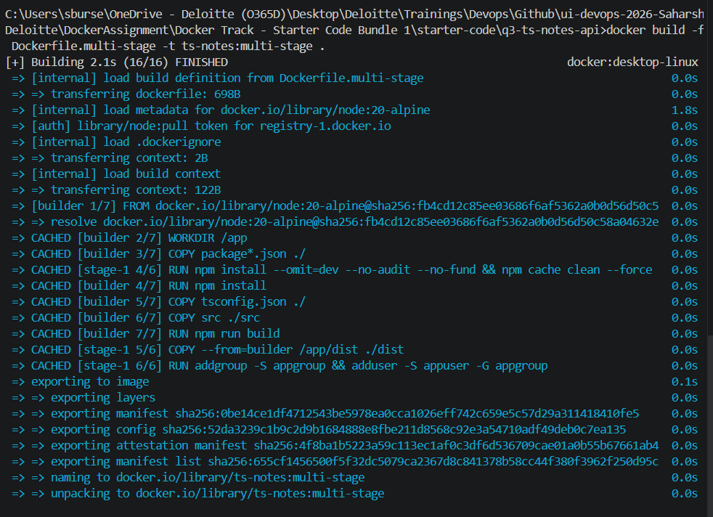
➢ Compare the two sizes and list, specifically, what is present in the single-stage image that is absent from the multi-stage image (for example: the TypeScript compiler, devDependencies, .ts source files, npm cache).
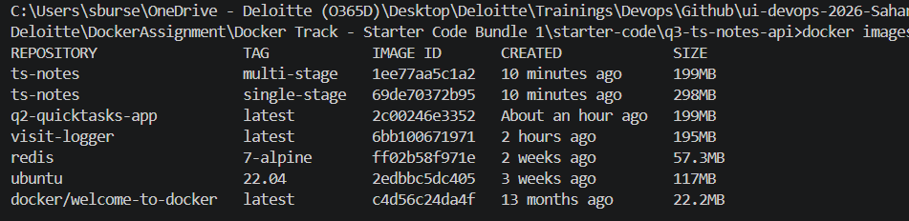

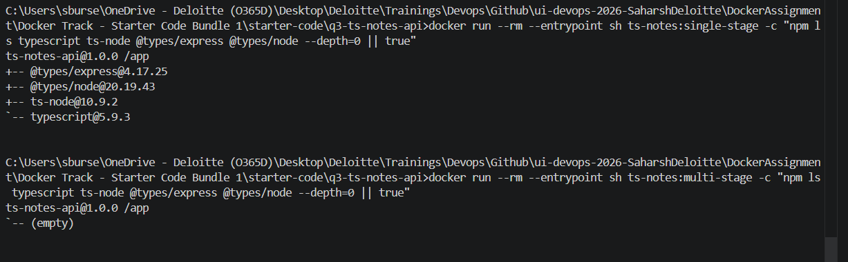
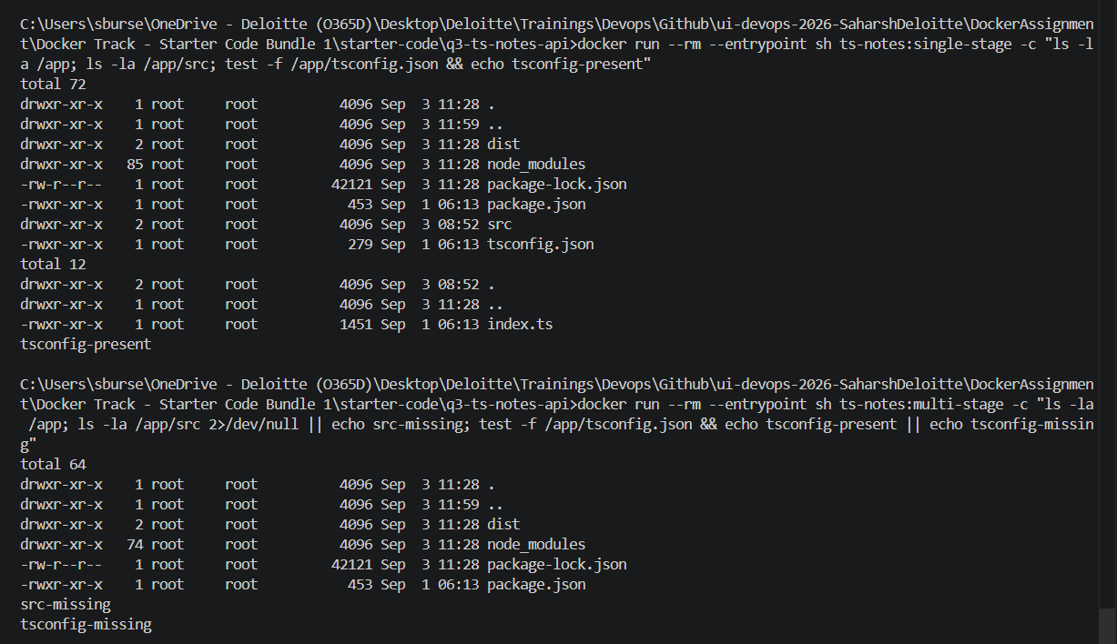
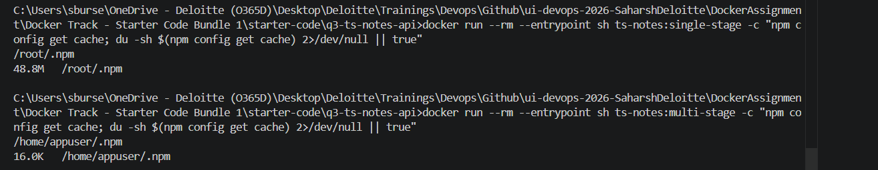

➢ Harden the multi-stage image: run the container as a non-root user that you create explicitly (do not rely on a base image that happens to default to non-root), and add a HEALTHCHECK instruction that checks the /health endpoint.
docker rm -f ts-notes-ms-test
docker run -d --name ts-notes-ms-test -p 3000:3000 ts-notes:multi-stage

➢ Run a container from the multi-stage image and use docker inspect (or docker ps) to show the health status transition from starting to healthy, and confirm which user the process is running as inside the container.
docker inspect --format "{{.State.Health.Status}}" ts-notes-ms-test

docker inspect --format "{{.Config.User}}" ts-notes-ms-test
➢ Provide the output of docker images and docker history for both images as evidence of the size difference and the layer structure.
